- The Budget on November 26 will be a key test of market confidence in the UK government's fiscal approach. If the government missteps and markets take fright, we think that sterling depreciation would accompany higher gilt yields.
- We've used our Global Economic Model to construct a scenario where markets react negatively to the Budget. A weaker pound would exacerbate the UK's inflation problems and discourage the Monetary Policy Committee from resuming rate cuts in early 2026. We think the government would then belatedly change its fiscal approach, cutting spending to try to restore confidence.
- Under this scenario, GDP would be 0.6ppts below our baseline forecast by the end of 2027. Consumers would be hit hard, with higher inflation adding to the squeeze on spending power. But the impact of a weaker pound on net trade would mitigate the hit to GDP.
- The UK's fragile fiscal situation is a function of its high deficits, high inflation, and low growth. The government's reliance on tax rises to lower borrowing is a key risk factor. Historically, revenue-based consolidations have a low success rate. Trying to raise large amounts of extra revenue from smaller taxes may also undermine the credibility of the government's plan.
Recent media speculation that the UK could face a repeat of the 1970s International Monetary Fund bailout exaggerates the scale of the UK's fiscal problems. But as the volatility in bond yields over the past year demonstrates, markets are concerned about the fragility of the UK fiscal outlook.
Our baseline forecast assumes that the government muddles through. We expect £20bn-£30bn of fiscal tightening in the Budget on November 26. The reduction in borrowing is likely to prove slower than the Office for Budget Responsibility anticipates, but we expect the government largely to keep markets onside.
However, with markets effectively giving the UK the benefit of the doubt, sentiment could turn rapidly, particularly if the government missteps. In this note, we set out how a scenario where markets lose confidence in the UK's fiscal approach might play out.
Chart 1: The UK's debt dynamics are weaker than those of most other advanced economies
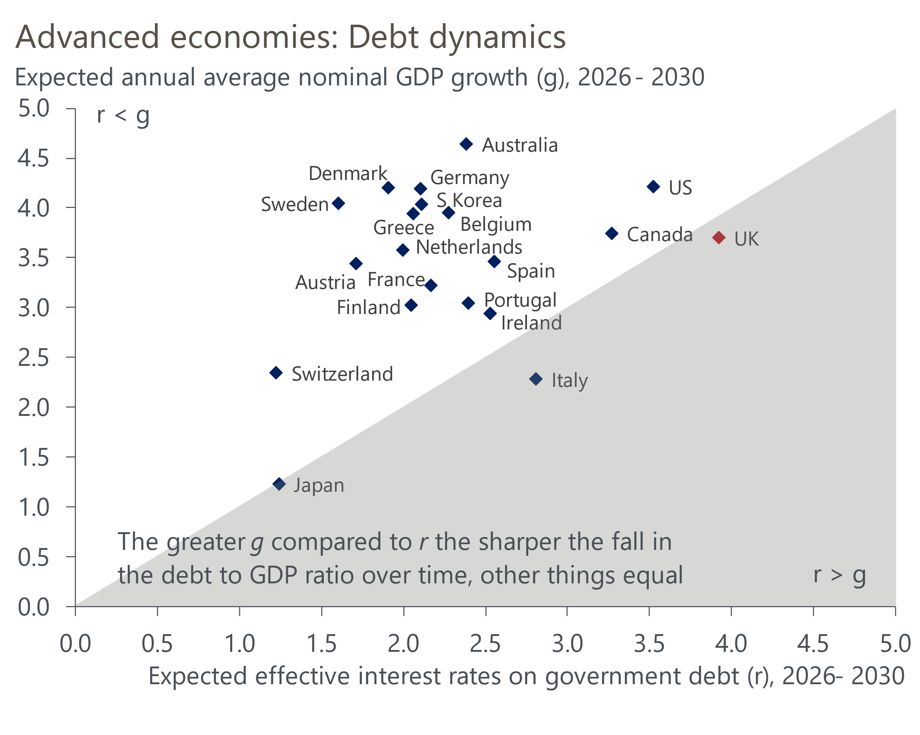
Source: Oxford Economics

High deficits, high inflation, and weak growth make the UK vulnerable
Of the G7 countries, only Germany has a lower level of gross government debt than the UK (Chart 2). But countries with much higher levels of debt can take advantage of structural benefits that the UK doesn't share: domestic savers provide strong demand for Japanese government debt; the European Central Bank effectively acts as a backstop for Eurozone countries; and the US has the world's reserve currency. By contrast, a greater proportion of UK government debt is held by foreign investors than is the case in most other countries, leaving the UK more reliant on 'the kindness of strangers'.
Chart 2: High deficits are the most pressing concern for the UK
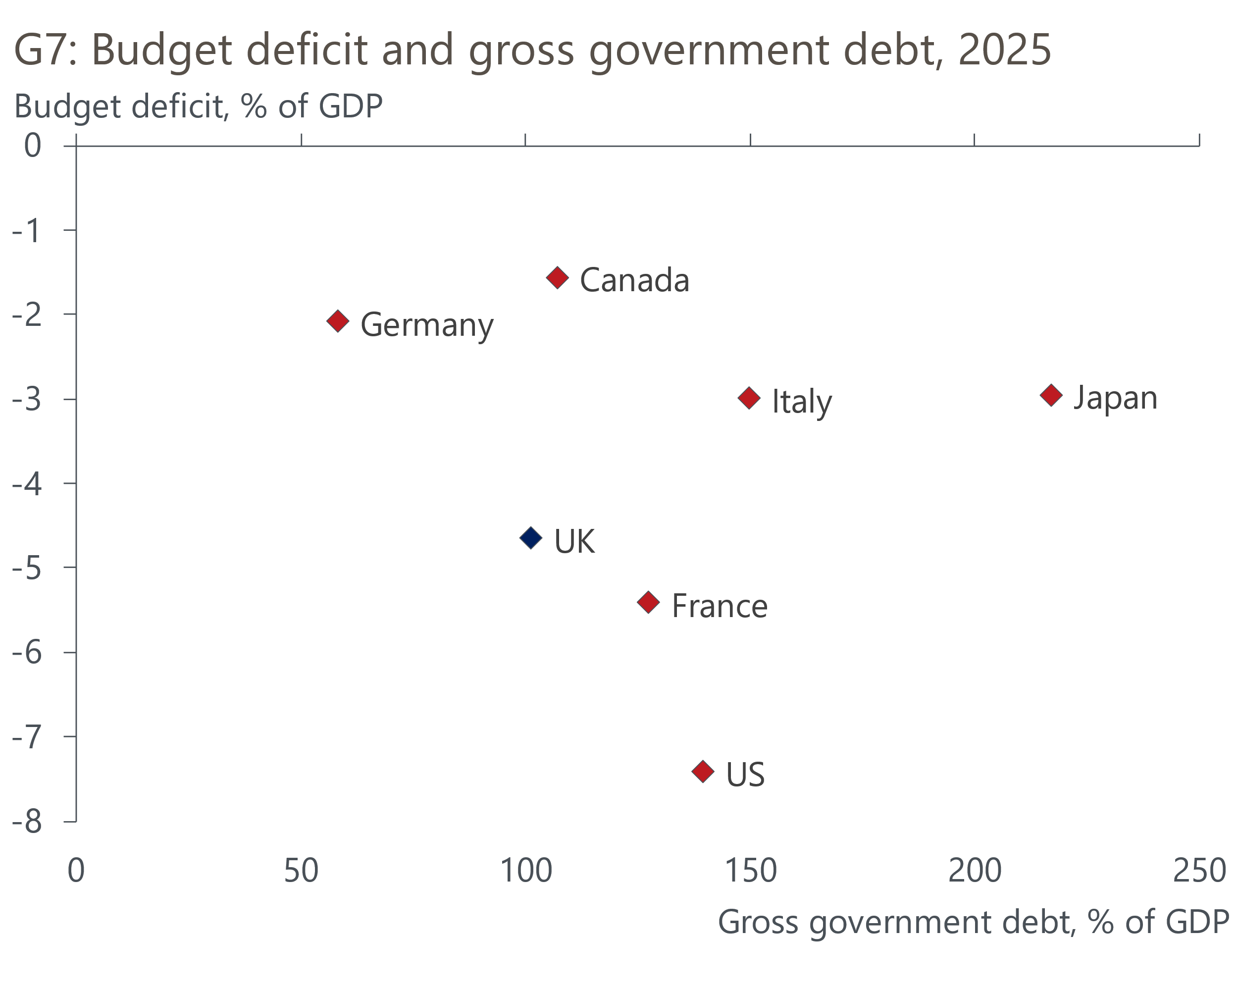
Sources: Oxford Economics, Haver Analytics
The UK also has one of the highest budget deficits in the G7 and, although it has a plan to reduce borrowing, history suggests tax-based consolidations have a high failure rate. That government borrowing outturns have consistently come in above the Office for Budget Responsibility's (OBR) forecasts in the fiscal year to date has reinforced concerns that the government's deficit-reduction plan may not be successful.
Term premia have risen across the world. But the increase has been particularly steep for the UK, which likely reflects a lack of confidence in the UK's fiscal approach (Chart 3). Concern that the government will be unable to orchestrate a recovery from the UK's dismal productivity performance is also a factor. Despite putting faster economic growth at the centre of its policy aims, the policies it has unveiled to date have been unconvincing.
Chart 3: UK term premium has risen sharply over the past couple of years
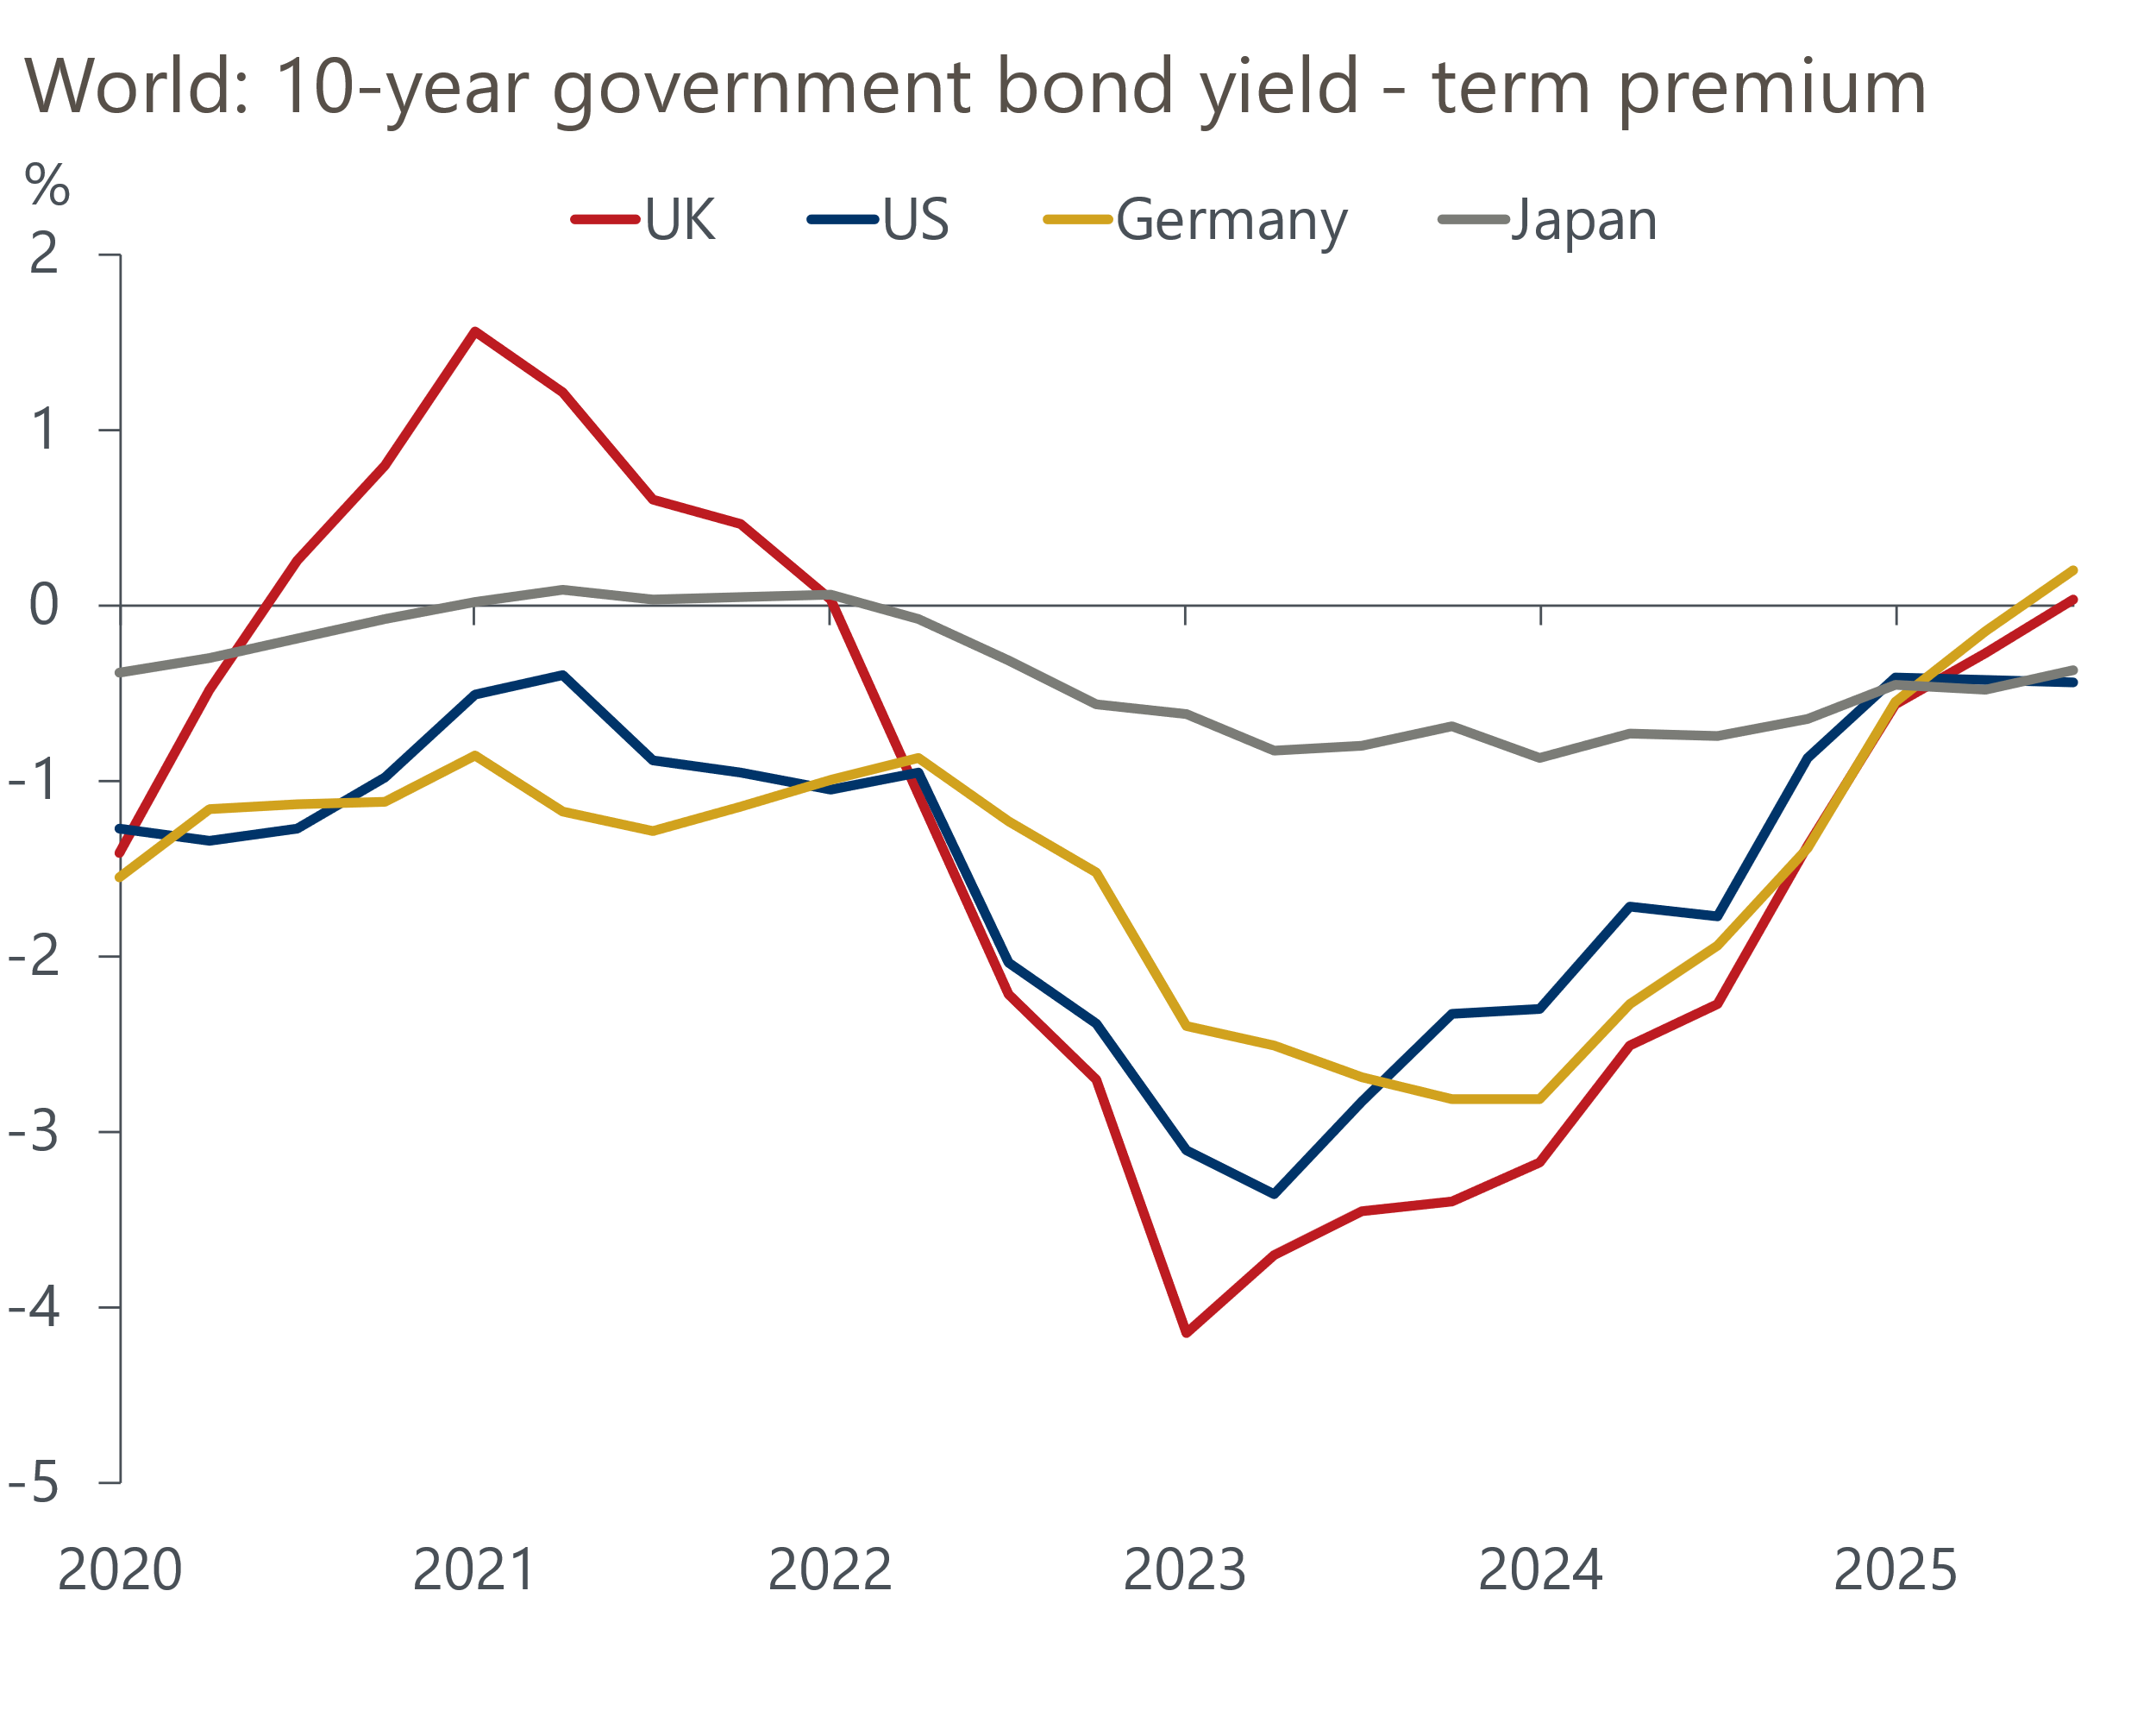
Source: Oxford Economics calculations using data from Haver Analytics
There's also been upward pressure at the shorter end of the curve. Sticky inflation has meant that markets think the Bank of England (BoE) is already close to the end of its rate-cutting cycle. We think the BoE is underestimating the role played by the increase in employers' national insurance contributions in keeping inflation high. We also expect GDP growth to undershoot the BoE's expectations. But although this should mean that the Monetary Policy Committee resumes loosening policy next year, we expect it to take a very cautious approach, limiting any fall at the shorter end of the curve.
As a result, the UK's debt dynamics look poor even under our baseline assumptions – where the UK muddles through with the term premium remaining close to current levels. We expect debt servicing costs to be slightly higher than nominal GDP growth over the next five years, with only Italy having worse debt dynamics among the advanced economies (Chart 1). This leaves the UK vulnerable to additional swings in market sentiment, so it's crucial that the government maintains the confidence of markets in its deficit-reduction plan.

The Budget is the obvious trigger for a loss of confidence
The Budget on November 26 will be the key test of the government's ability to sustain market confidence. And last year's edition provides a warning of the potential pitfalls. Gilt yields rose sharply because the government delivered a package that was different to what it had led markets to expect, involving extra borrowing to fund day-to-day spending and leaving little headroom against future shocks.
This time, there's broad agreement that OBR forecast revisions are likely to require the government to tighten policy by £20bn-£30bn to remain compliant with its fiscal rules with a similarly slim degree of headroom. It's inconceivable that the government will present a Budget that the OBR judges isn't consistent with the fiscal rules. But the choice of measures and their credibility will be very important for markets. The likelihood that Chancellor of the Exchequer Rachel Reeves again leaves a small margin for error makes it even more important that she can convince markets that the policies will succeed in lowering borrowing.
We laid out our expectations of what the government will do in a recent note. As we've already argued, revenue-heavy consolidations have a high failure rate, so the likelihood that the chancellor will rely on further tax increases to plug most of the fiscal hole is a big credibility risk. The choice of tax rises will likely further increase the risk of failure. As well as extending the freeze on most tax allowances and thresholds, we expect the government to repeat last year's ploy of targeting large increases in revenue from a series of smaller taxes. But the success of this approach is uncertain. The behavioural responses from large tax changes may prove greater than expected, and – because those facing large tax hikes may complain vociferously – this strategy may also not be politically viable. There's a risk that markets will be similarly unconvinced.
In addition, the chancellor has raised the prospect of switching from two OBR forecasts a year to one. This would be consistent with her aim to have only one fiscal set-piece event a year. But given the government is starting from a position of weakness, announcing this plan at the Budget would be a risk. As with the sell-off that followed the September 2022 mini-Budget, markets could perceive this as an attempt to reduce expert scrutiny of the government's fiscal plans.

If markets lose faith, how would this scenario play out?
The experience of former Prime Minister Liz Truss could provide a template for the initial reaction if markets decide that the Budget doesn't offer a credible deficit-reduction plan. In the immediate aftermath of the 2022 mini-Budget, gilt yields rose and sterling weakened.
As we argued in a recent note, the UK is particularly vulnerable to depreciation against the dollar now because its recent strength has largely been due to dollar weakness, and our strategy team's suite of long-term FX models suggest sterling is trading meaningfully above fair value against the dollar. In our alternative scenario, sterling quickly falls to $1.20 and remains there throughout 2026 (baseline: $1.34).
Regarding gilt yields, a lack of confidence among market participants that the tax rises will yield the uplift in revenue that the OBR anticipates would cause the term premium to rise further.
The sterling depreciation would exacerbate the UK's existing problem with sticky inflation. Under our baseline forecast, we expect the Monetary Policy Committee to resume rate cuts in early 2026. But in this scenario, headline inflation would stay higher for longer, leaving the MPC reluctant to cut for fear of stoking inflation. So, Bank Rate would stay at 4% throughout 2026, rather than dropping to 3.5%.
The combination of upward pressure at the shorter end of the curve and a more elevated term premium would see the 10-year gilt yield average 4.9% over the next six months (Chart 4). We don't expect this would trigger a 2022-style rescue from the BoE, because the decline in leveraged liability-driven investment since then reduces the risk that rising yields would trigger aggressive forced selling and resultant financial instability. Still, this rise in yields would reinforce the cycle the government has found itself in, where a combination of rising debt servicing costs and ineffectual tax rises erodes the slim headroom the chancellor has left herself, forcing another round of tightening at the next fiscal event.
Chart 4: If markets lose faith, sterling could fall sharply alongside higher gilt yields
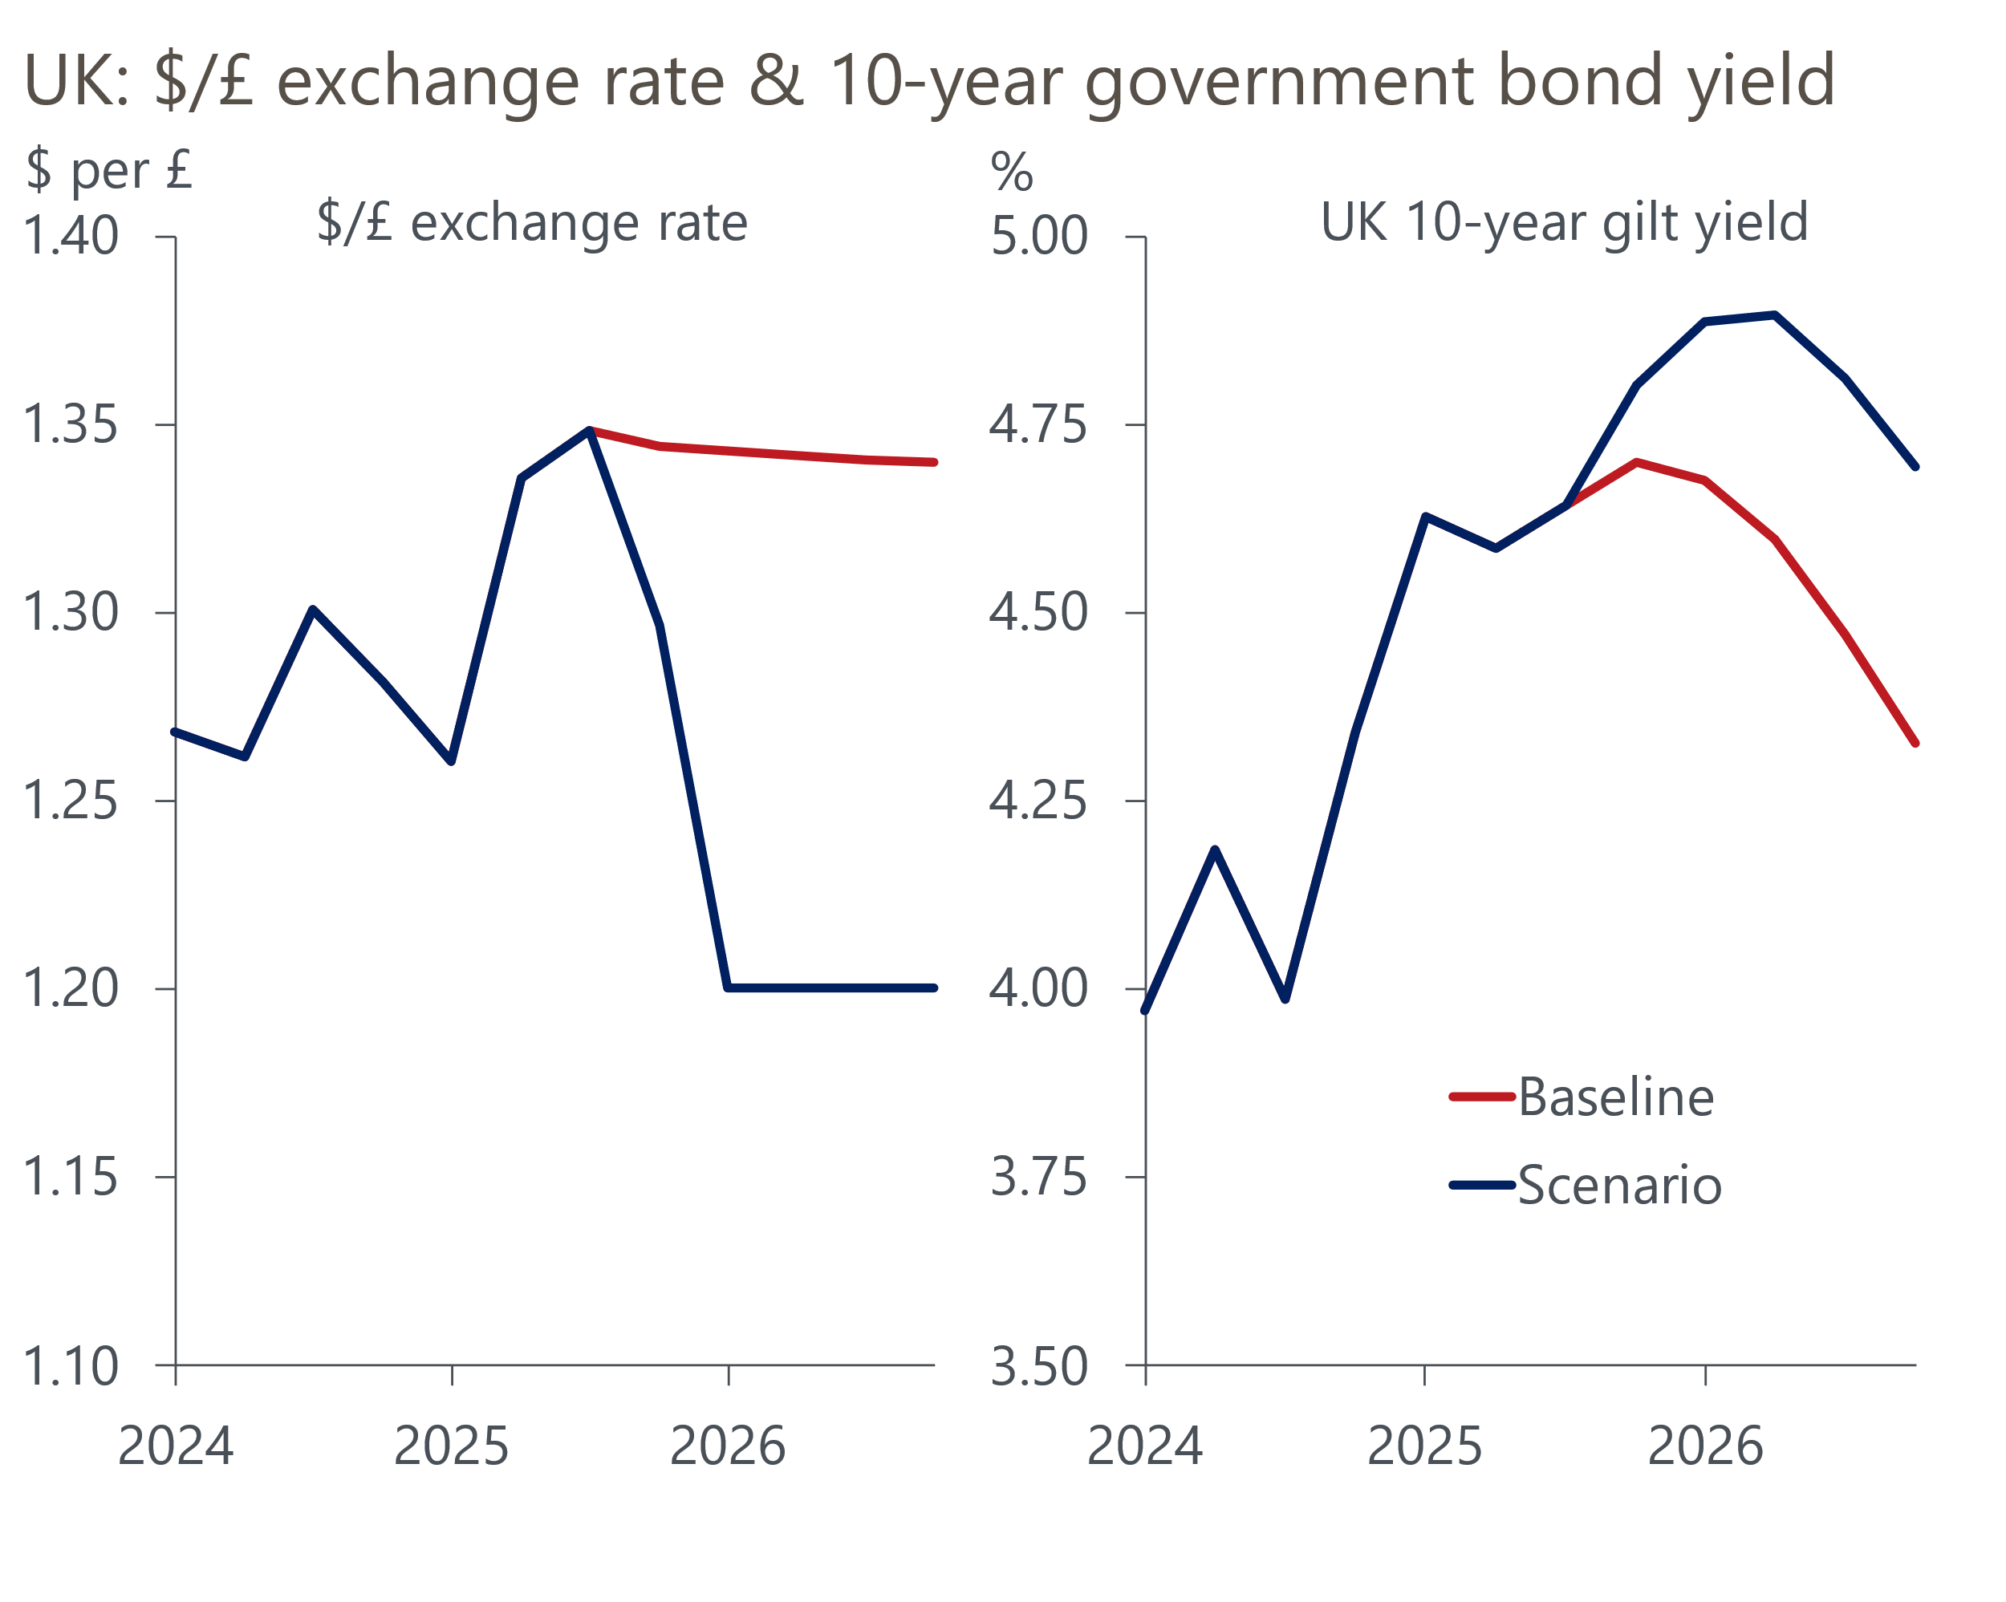
Sources: Oxford Economics, Haver Analytics
In our downside scenario, we assume another thumbs down from markets finally leads the government to pursue a different fiscal approach, committing to cutting spending from the start of fiscal year 2026-2027 through a combination of lower departmental spending and welfare reforms.

Downside scenario sees even weaker growth in 2026-2027, with the consumer badly hit
We've run our scenario assumptions (Box 1) through our Global Economic Model to assess the wider impact on the economy. Our baseline forecast shows GDP growth of just 0.9% in 2026, below the consensus of 1.1% and well short of the OBR's March forecast of 1.9%. In our alternative scenario, GDP growth drops to just 0.8% in 2026 and, by the end of 2027, the level of GDP is 0.6ppts below our baseline forecast (Chart 5).
Chart 5: Higher exports and lower imports would mitigate a much weaker consumer outlook
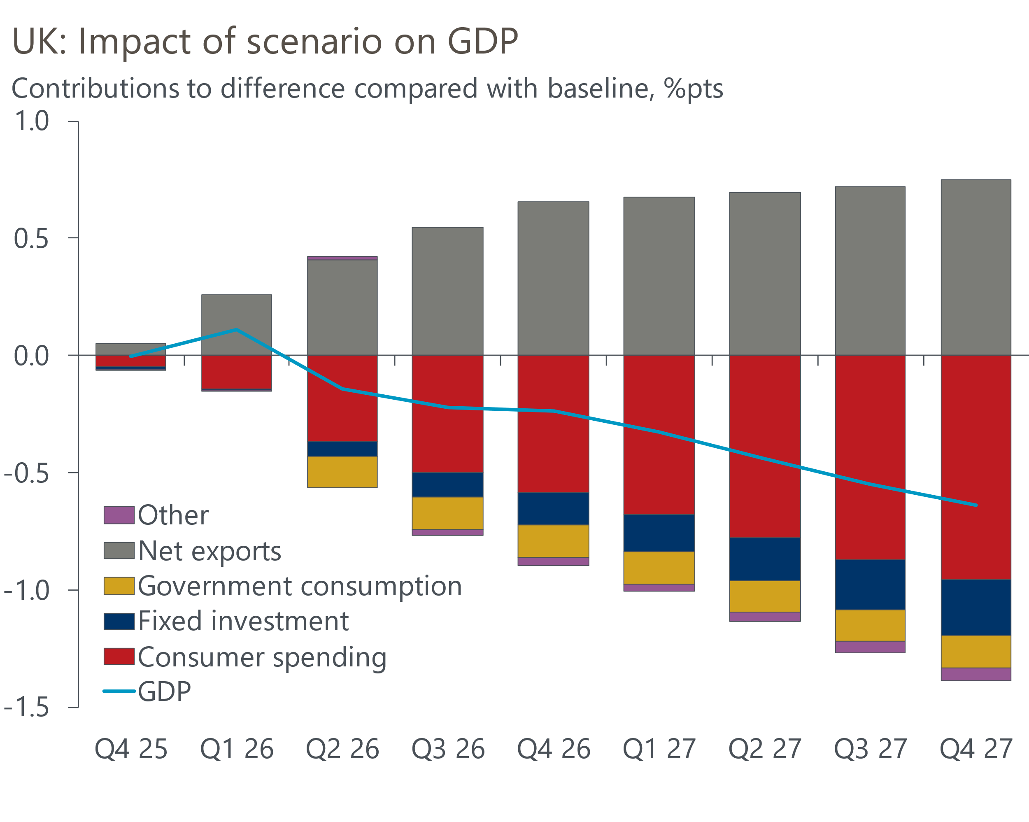
Sources: Oxford Economics, Haver Analytics
But this masks some much larger divergences in the fortunes of different parts of the economy. Consumer spending is hit hard, growing by just 0.4% in 2026 and 2027 (baseline: 1.1% and 1.1%). This reflects a bigger squeeze on spending power from high inflation (Chart 6), as well as lower employment resulting from weaker public sector job creation.
Chart 6: Sterling depreciation would exacerbate the UK's inflation problem
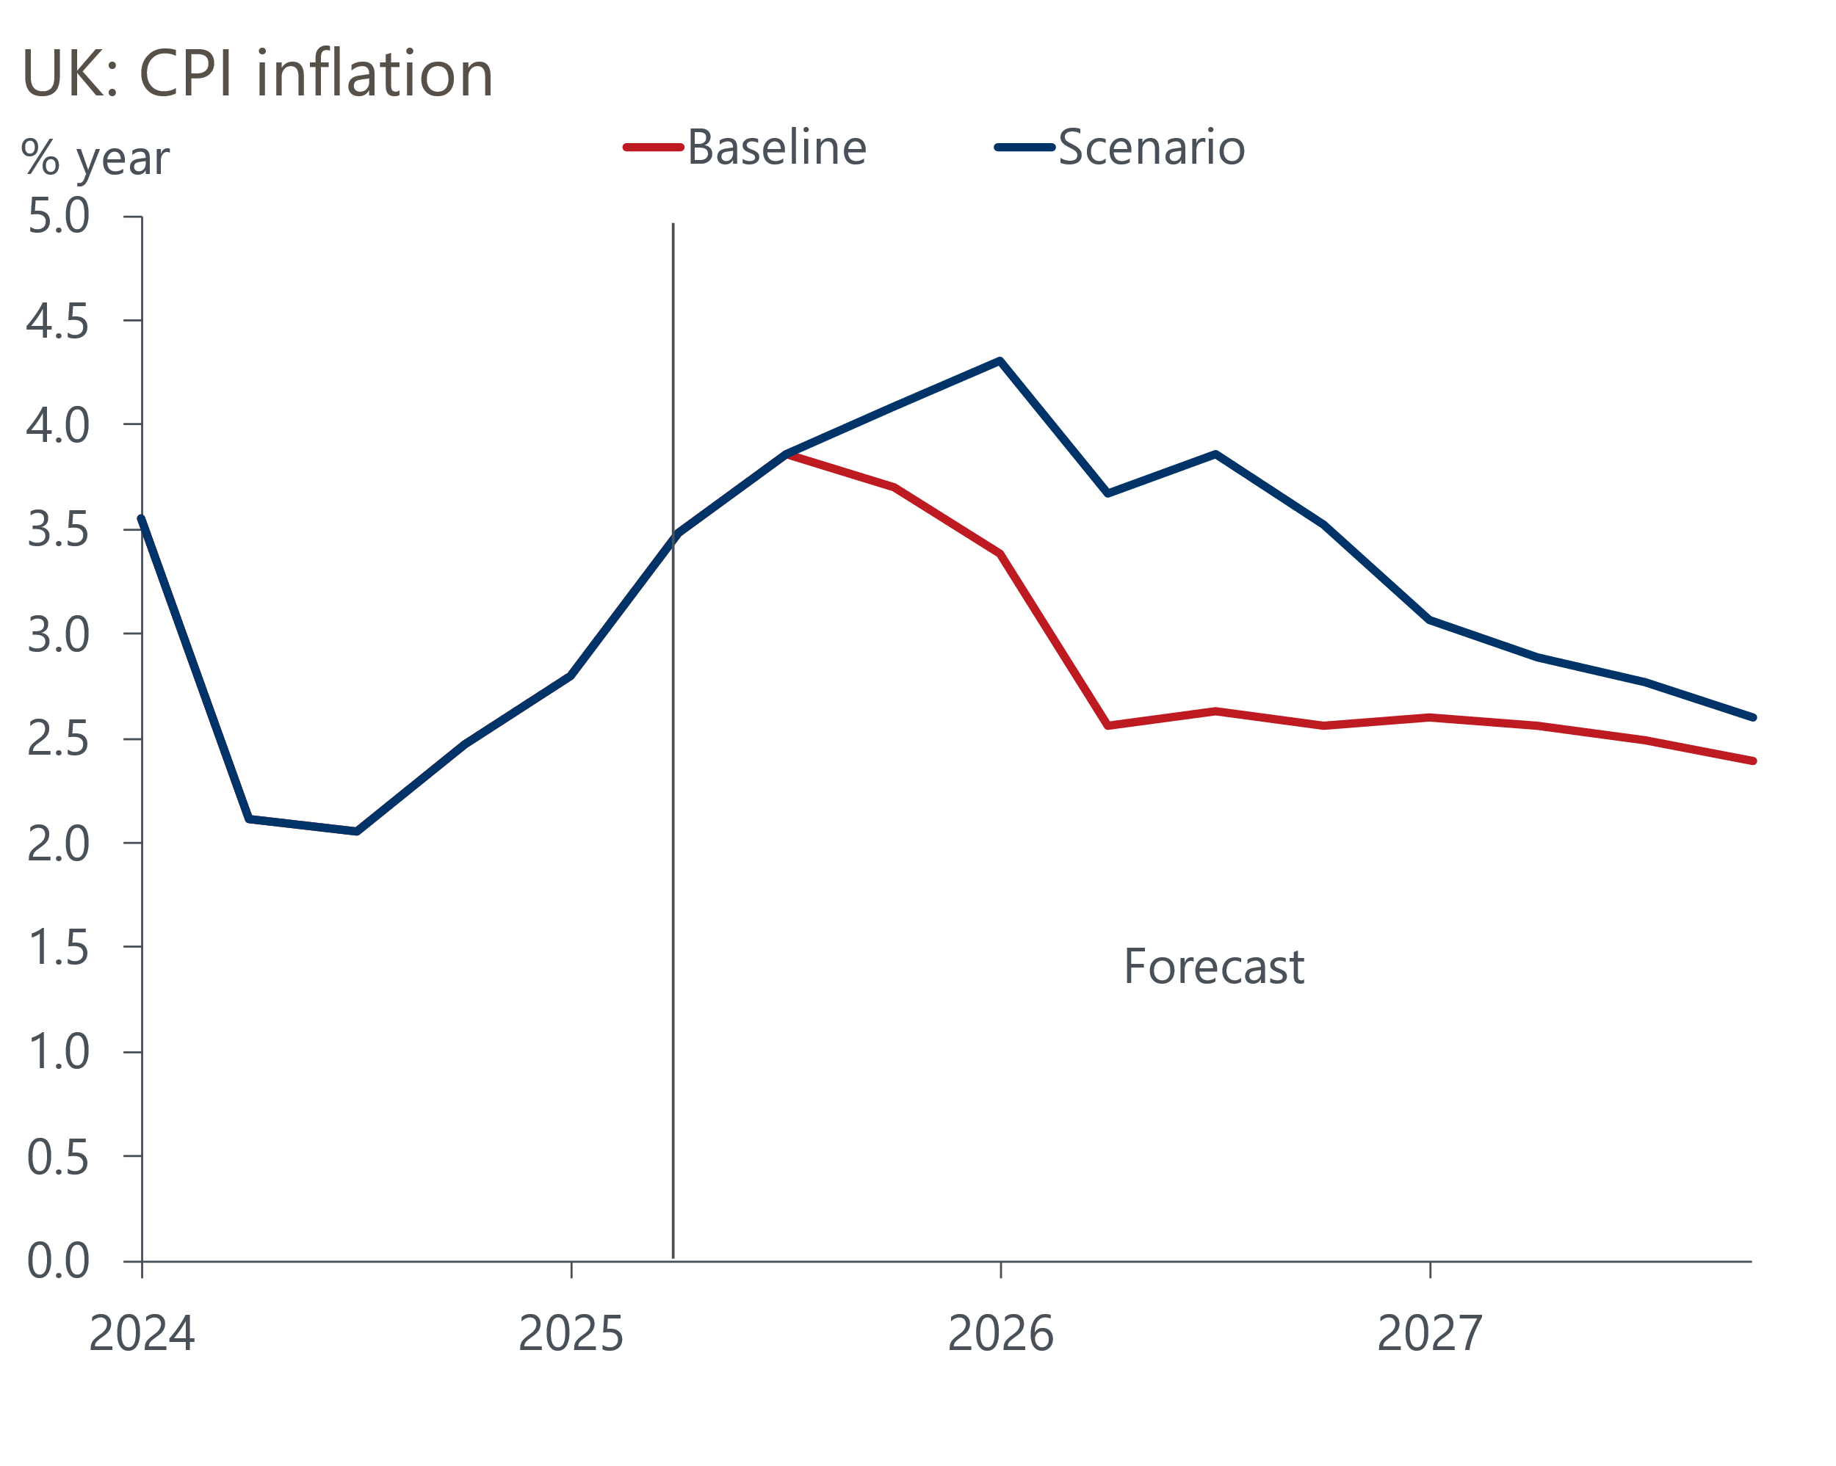
Sources: Oxford Economics, Haver Analytics
However, stronger net trade performance mitigates the hit to GDP. This is partly a function of a weaker pound boosting exports and constraining imports. But imports would also be hit by weaker consumer demand.

Box 1: Scenario assumptions
- GBP/USD drops to $1.20 after November's Budget and remains at that level throughout 2026.
- Bank Rate remains at 4% until end-2026.
- Term premium on 10-year gilt yield rises 10bps above the baseline forecast, then falls back from mid-2026 once the government has changed tack and implemented spending cuts.
- Public sector current expenditure is 1% lower than the baseline forecast from the start of fiscal year 2026-2027.
- Welfare spending is £5bn lower than the baseline forecast from the start of fiscal year 2026-2027.

